Backyard Basketball Games
We’ve compiled a list of our favorite backyard basketball games to try from home. These games only require one to two people. If you are without a hoop at home, try substituting a bucket or nerf hoop.

GOLF

Equipment: Printable scorecard, pencil/pen, basketball, basketball hoop, chalk or cones.
Players: 1+
How to play:
- Played like the game of golf, a player will get a stroke for every shot taken to get the ball in the hoop.
- Setup the golf course by placing cones or chalk marks on the court. Each cone/mark will symbolize a different hole. Vary the distances just like in golf, create some challenging shots (par 5) and some easy shots (par 3)
- Each player will shoot from the starting cone/marker. If the ball makes it into the hoop on the first try they will mark a 1 on their scorecard. If the ball misses they will get their rebound and shoot from that spot, continuing to rebound and shoot until the ball goes into the hoop adding up their strokes (shots) the entire time. Remember to mark your scorecard. Find a printable scorecard here.
- Player with the lowest score wins, or if playing alone try to score under par or beat previous round.

AROUND THE WORLD

Equipment: Basketball, basketball hoop, chalk or cones.
Players: 1+
How to play:
- Create a semicircle on the court and mark 5 to 10 different shooting stations around the semicircle.
- All players will start from the same side of the court (starting on the baseline) at the same station.
- The first player to shoot if they make it they will move to the next shooting station and shoot again. Continuing to shoot and move “around the world” as they make baskets.
- If the player misses they can either choose to chance it (take another shot) or stop their turn. If they chance it but miss they have to start back at the beginning again. If they choose to stop their turn they get to stay at the shooting station of the last made shot.
- Play continues until the first player completes all of the shooting stations.
Variations
- If you miss any shot you have to go back to the beginning station on your next turn
- Giving each player one immunity, where they can take one chance shot without consequences of missing
- Start and end the game with a lay-up
- Start and end with a shoot from the free-throw line

STEP BACK

Equipment: Basketball, basketball hoop, chalk or cones
Players: 1+
How to play:
- Similar to the concept of Around the World, player(s) will shoot from a starting point 2 FT from basket.
- Each shot they make they will take one step back from the hoop.
- If the player misses they have to go back to the starting point.
- Mark each new step back with a cone or chalk line to keep track of your furthest record or if playing against a friend, set a time limit and the player with the furthest mark from the hoop wins.

SKILLS CHALLENGE

Equipment: Basketball, basketball hoop, chalk or cones, other obstacle equipment
Players: 1+
How to play:
- Create an obstacle course out of objects from home.
- Add different skills within the obstacle course, dribbling, shooting, passing, footwork slides.
- Players are timed as they facilitate the course. Fastest time wins, if only one player try to beat your previous time.
Course equipment & setup ideas
- Garbage can or chair to use as a defender to move or shoot around
- Jump ropes or hula hoops
- Draw a agility ladder with chalk
- Example below
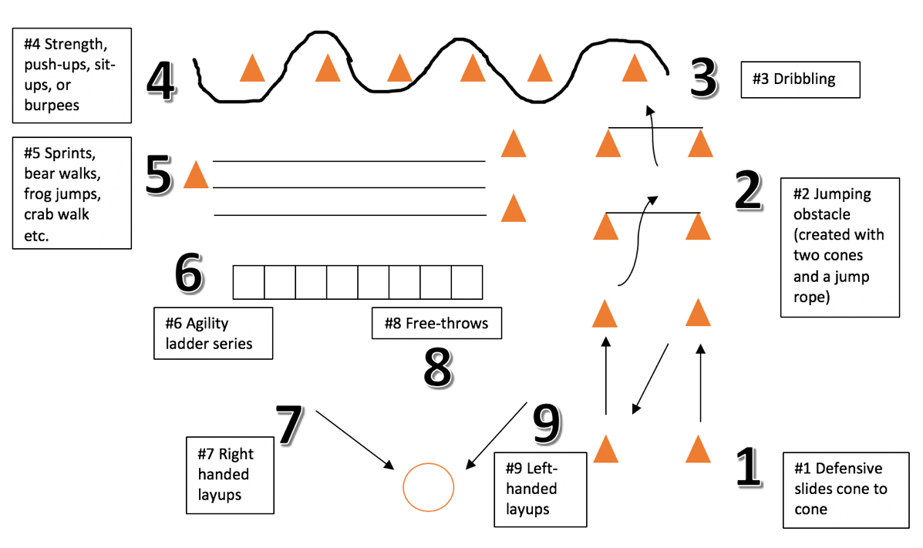

RECORD BREAKER

Equipment: Basketball, basketball hoop chalk or cones

Players: 1+
How to play:
- Time yourself doing different challenges
  - How many shots can you make in a minute
  - How many layups
  - How many times can you get through a set of cones dribbling
- Record High: what is the highest number of different skills you can do consecutively
  - How many shots from the elbow can you make in a row
  - How many free-throws can you make in a row
  - How many dribbles in a row
  - How many layups

BUZZER BEATER

Equipment: Basketball, basketball hoop

Players: 1+
How to play:
- Imagine, it’s the 4th quarter, 3 seconds are remaining on the clock, your team is down by 2 points and you just received the inbound pass near half court. You take two dribbles, shoot and you score! So this really isn’t a game but really fun to practice that history making half-court buzzer beater!
- After you hit the shot make sure you deliver an epic celebration

TRICK SHOT COMPETITION

Equipment: Basketball, basketball hoop

Players: 1+
How to play:
- Behind the back, under the legs, eyes closed, behind the basket, all count!
- Get bonus points for creativity and difficulty, anything goes.
- Record your trick shot and have an online trick shot competition with your friends, everyone votes on the best trick shot.
- Trick Shot challenge, challenge a friend to imitate your trick shot or imitate your favorite basketball player.

ONE ON ONE

Equipment: Basketball and basketball hoop

Players: 2+
How to play:
- Each player is his/her own team. Play until first player gets to agreed-upon final number of points.
- Only one basket is needed, to reset the possession dribble the ball to the free-throw line or outside the three point line.
- If ball goes out of bounds, check (pass to the defense, they will pass it back, signaling they are ready to resume play) the ball at the top of the key (near 3 point/free-throw line).

SHOOTING COMPETITIONS

Equipment: Basketball and basketball hoop

Players: 1+
Variations:
- 3 Point Contest
- Free-Throw Contest
- All-Star Shootout – draw circles with chalk in different distances and difficulty on the court and mark point values for different distances. The higher the points for the more difficult shots. Set one minute on the clock and shoot as many shots as you can for the different circles. Person who tallies up the most points wins
- Slam Dunk Contest – lower that rim (or not) and practice those dunks. Remember you get judged on style, creativity and athleticism!

HORSE

Equipment: Basketball, basketball hoop

Players: 2+
How to play:
- First person shoots, if they make it second player has to shoot from same spot, if they miss they get a letter
- Second player gets to shoot from any spot after the first player misses a shot, if they make it the first player has to shoot from that spot
- The first player to spell the word HORSE loses

KNOCKOUT (LIGHTNING)

Equipment: Basketball, basketball hoop

Players: 2+
How to play:
- First person shoots a free-throw, gets rebound and continues to shot until they make the shot
- Second player starts to shoot after first person shoots
- After each player makes the shot they go to the end of the line keeping the same order
- To knock someone out of the game you need to make the shot before the person in front of you makes their shot. If the person behind you makes their basket before you, you are out
- The game is played until only one player remains

